**Project Proposal**

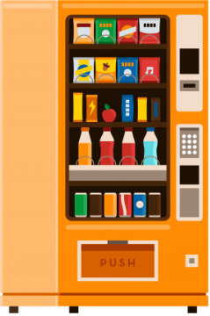

**VENDING MACHINE SIMULATOR**

**Group Information**

|  |  |
| --- | --- |
| **Name** | **Student ID** |
| **Muhammad Asad Ullah** | **62985** |
| **Syed Muhammad Nabeel Ali** | **63027** |
| **Muhammad Hanif** | **63060** |

**­­­­Use Case Analysis**

**User Type: Customer**

**User Type: Maintenance Employee**

**User Type: Administrator**

­­­

Admin

**Users Analysis**

There are three user groups for this program as Follows:

**1. Customer**

Customer is the main user for this machine, is a person who is willing to buy something from vending machine against payment.

* Customers can be of different age groups but they mostly consist of age 10+ but digital payment feature is only for people with NIC.
* Customers are irrespective of gender.
* Customers are familiar with smart devices and their function
* Customers do not have any impairment.
* Customers must be capable enough to read and write Basic English.
* Customers may be hungry or it is their snack time.
* Customers are not very concerned with not eating outside food.

**2. Maintenance Employee**

Maintenance staff can consist of one person or more than one person but not many people.

* This user is an energetic and conscious person which is aware of its surrounding.
* Maintenance employee works in off hours when there are not many people out.
* This type of user mostly implies to male genders.
* This person must be familiar with using mobile.
* This person may be capable enough to read and write Basic English.
* This guy is authorized by administrator.
* This person probably has a vehicle which he uses to carry items for vending machine.

**3. Administrator**

These person setups the vending machine and receive the payment from machine. This person keeps track of all the machine information and operation status via some remote access. He also views the overall sales report of vending machine so to analyze how it is going.

* Administrator must be capable enough to read and write Basic English.
* Administrator must be used to managing finance and keep track of debit and credit.
* Admin is irrespective of Gender.
* Admin should be active and responsive person.
* Admin must be familiar with using smart phone.
* Admin must be NIC holder and have a bank account.

**Task Analysis**

These are some various tasks performed by Users

**Customer:**

* Customer can Top Up his VM wallet using different payment method like cash, easy paisa, jazz cash, debit card or credit card.
* Customer can choose any item in any desired quantity.
* Customer gets a receipt of purchased item before and after confirming order.
* Customer can get his order by scanning QR code and paying cash if he/she has selected to choose by cash.
* Customer can cancel his order and redeem his payment within 30 minutes of order.
* Customer can give feedback about vending machine i.e. give suggestion to add new item.
* Customer can file complain about any issue.
* Customer can create and save regularly consumed items in a cart.
* Customer can view his purchase history.
* Customer can redeem loyalty award points.
* Customer can get nearby vending machine notification.
* Customer can locate nearby vending machine.
* Customer can send paid cart as gift to someone.

**Maintenance Guy:**

* This guy can lock and unlock the shelf of vending machine.
* This guy check stocks items and update stock information in database using mobile interface.
* This guy can add new items and replace old items in vending machine on manager’s request.
* This guy is responsible to maintain the stock of items in vending machine.
* This guy checks the operation status of Vending machine like temperature, motor functioning, lightening and update this in database.
* This guy view complains by customer and take action on genuine complains. For example, He will approve redeem of payment for a customer whose item has been stuck.
* This guy ensures that Vending machine is working fine and call a technician in case of any problem.
* This guy withdraws cash and updates the amount in app.

**Administrator:**

* Admin keeps track of machine operation via a mobile application interface via remote means.
* Admin is immediately notified if someone tries to break vending machine for theft purpose.
* Admin can remotely turn on and off the vending machine.
* Payments by digital means are transferred to administrator account and are shown in app.
* Administrator gets the sales report of vending machine on daily basis.
* Admin can award loyalty awards points to regular customer.
* Admin can view feedbacks
* Admin can view complains
* Admin can request addition of new item or removal of old items to maintenance employee.
* Admin can update price of any item.

**Hierarchical Task Analysis**

**Note: Operations with green color are performed physically at vending machine.**

**CUSTOMER**

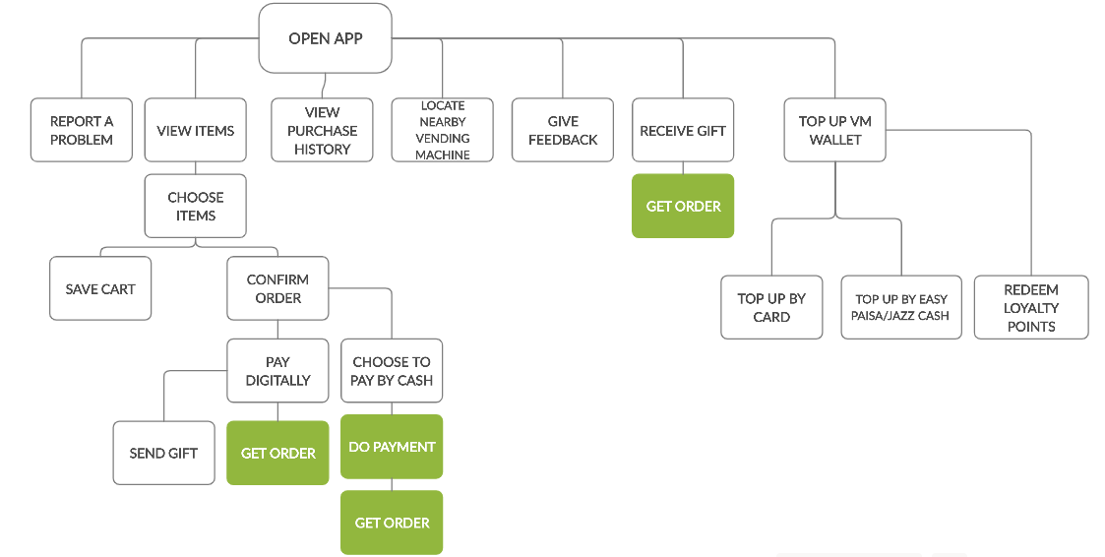

**MAINTANENCE EMPLOYEE**

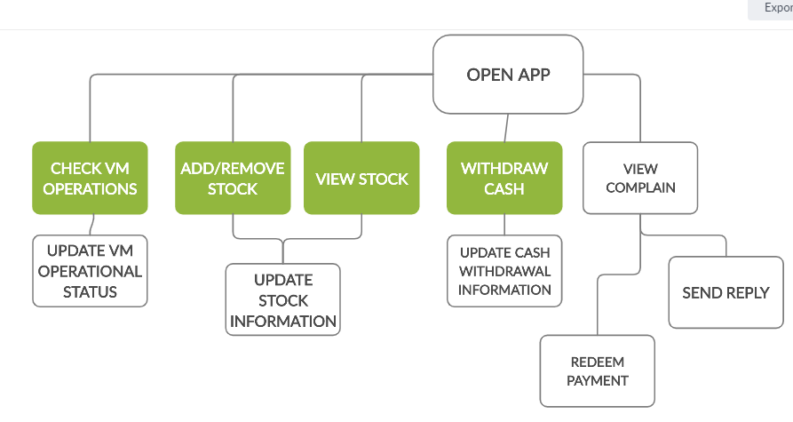

**Administrator**

